**JACK N JILL SCHOOL**  
BUDSHAH COLONY,SANAT NAGAR BY-PASS   
SRINAGAR

**WINTER ASSIGNMENT**

**NURSERY**

**Guidelines:**

* Parents are requested to encourage your child to use jumbo crayons for enhancing pencil gripping.
* Assignments and project work should be submitted on the first day after winter vacations.

**EPL (EXERCISE OF PRACTICAL LIVING): *to be practiced daily***

1. **Elementary movements:** SCISSOR CUTTING, FOLDING AND UNFOLDING
2. **Self-care**: FACE WASH, BRUSHING, COMBING, TOILET HABITS
3. **Environmental care:** USE OF TRASH BIN, CLEANUP TIME AFTER PLAY.
4. **SOCIAL SKILLS/PRACTICAL LIFE SKILLS:** GREETING ELDERS, USE OF BASIC CURTSY WORDS (THANKYOU, WELCOME, PLEASE), ENCOURAGING GROUP DISCUSSIONS AT HOME.
5. **Sensory skills:** differentiate between hot /cold, sweet/salty, loud/quiet, far/near
6. **Fine motor skills:** make a necklace of ten beads of different shapes and sizes,
7. **Gross motor skills:** physical exercises, running, jumping, free outdoor play.

**Project work:**

1. Take a chart paper and stick pictures of: sparrow, owl, crow, eagle, pigeon, hen, rooster, parrot, and duck.
2. Take a chart paper and stick pictures of: dog, cat, sheep, goat, cow, pig, horse, lion, elephant, snake, tiger, fox, and bear.
3. Take a chart paper and stick pictures of: bee, housefly, ant, spider, mosquito, caterpillar, butterfly, lady bug, grasshopper, dragon fly.

**ORAL SKILLS/VERBAL COMMUNICATION**

**Encourage your ward to answer in complete sentences for language development.**

1. WHAT IS YOUR NAME? My name is ………………
2. HOW ARE YOU? I am fine. Thank you.
3. HOW OLD ARE YOU? I am 3 years old.
4. WHAT IS YOUR MOTHERS NAME? My Mother’s name is…………
5. WHAT IS YOUR FATHERS NAME? My father’s name is………….
6. WHAT IS YOUR SCHOOL NAME? The name of my school is Jack N Jill.
7. WHERE DO YOU LIVE? I live at …………..
8. WHICH COLOUR DO YOU LIKE? I like………….
9. WHAT IS YOUR TEACHERS NAME? The name of my class teacher is……………..
10. LEARN ANY 5 RHYMES.
11. ORAL RECITATION OF A-Z
12. ORAL RECITATION OF 1-20
13. AWAL KALIMA.
14. WHO CREATED US? ALLAH SWT created us.
15. WHO IS OUR PROPHET? Prophet Mohammad Rasool SAW is our beloved prophet.
16. WHO ARE WE? We are Muslims.
17. DUA BEFORE EATING AND FINISHING FOOD?
18. DAYS OF THE WEEK.

**WORKSHEET:**

* **FINGER PAINTING ACTIVITY:**

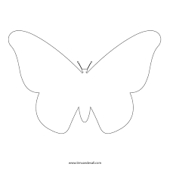

* **HAND PRINTING ACTIVITY:**

**(***Put handprint and PASTE pictures of family members on each finger***)**

* **PRE-WRITING SKILLS:** 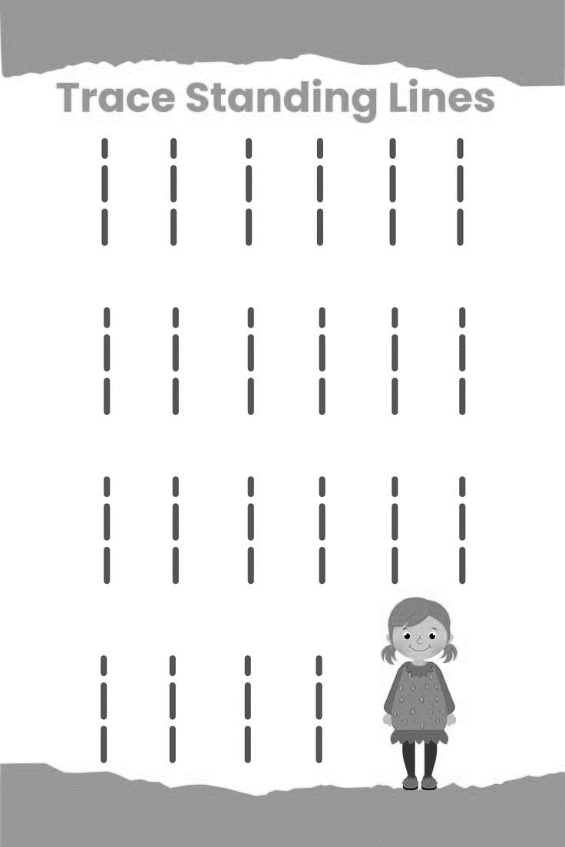

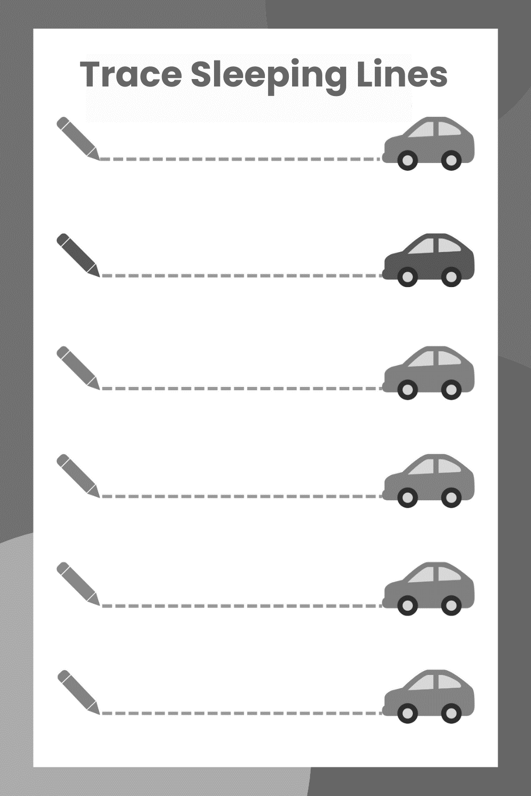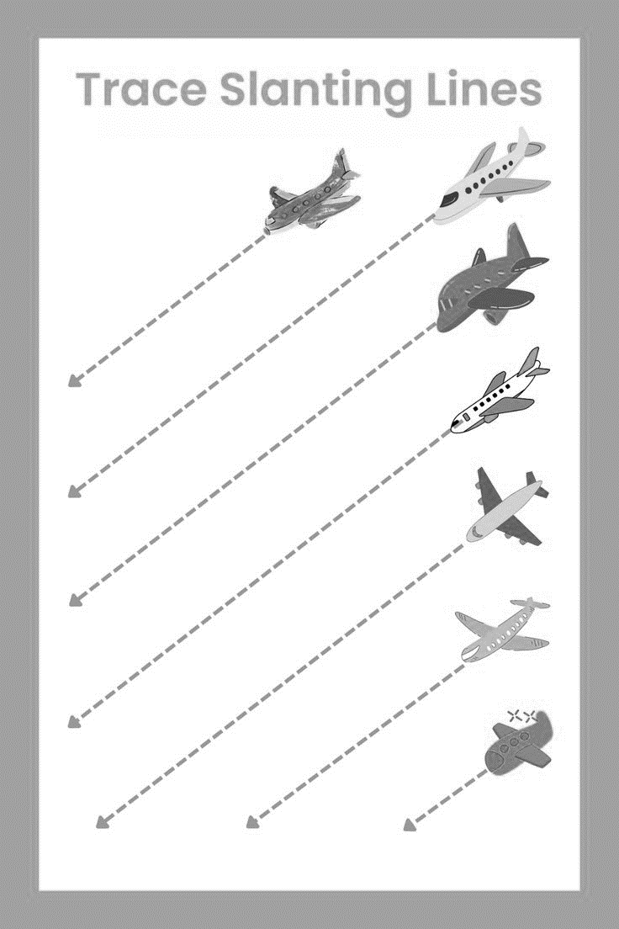

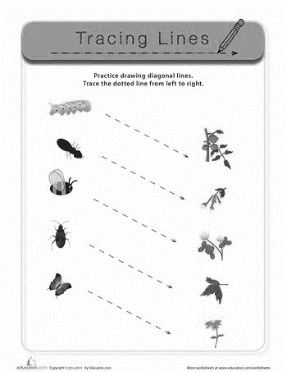

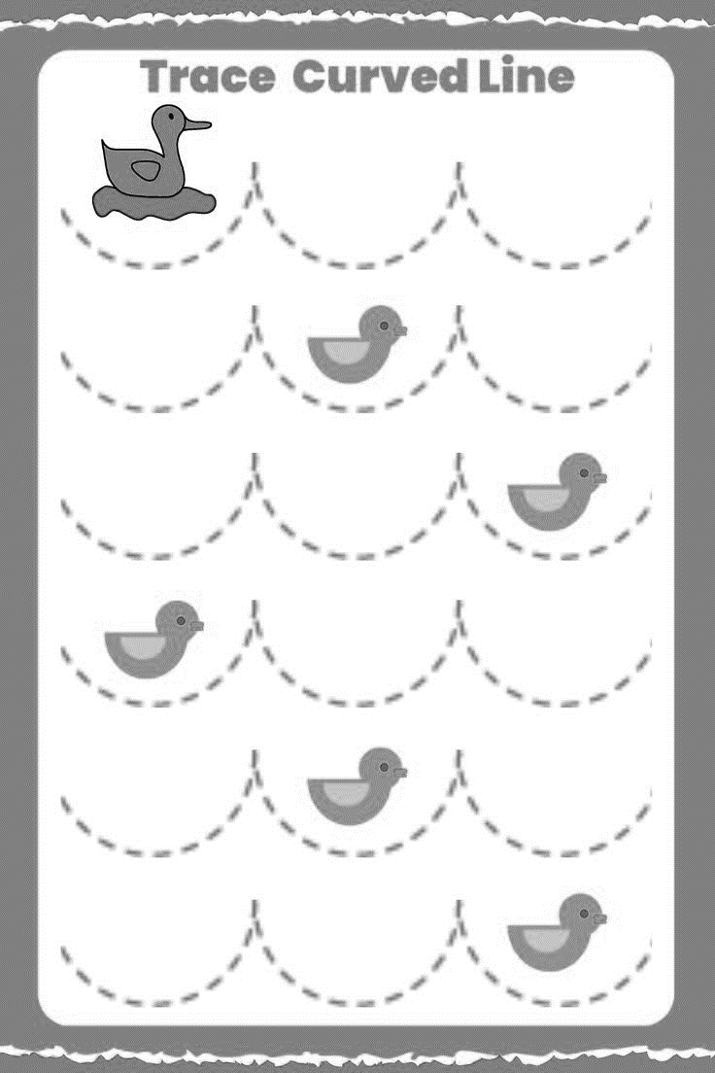

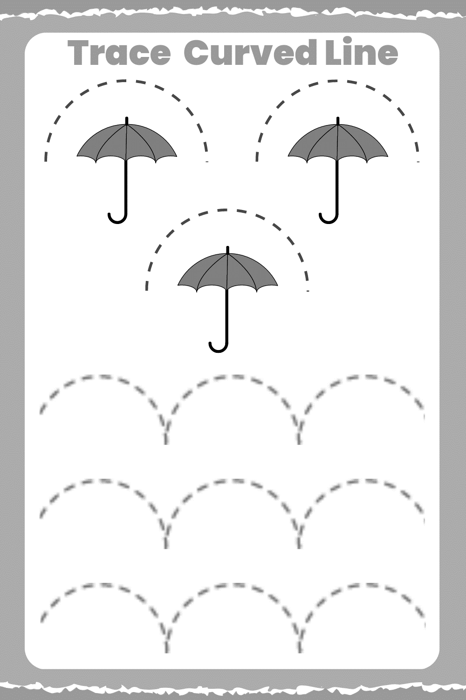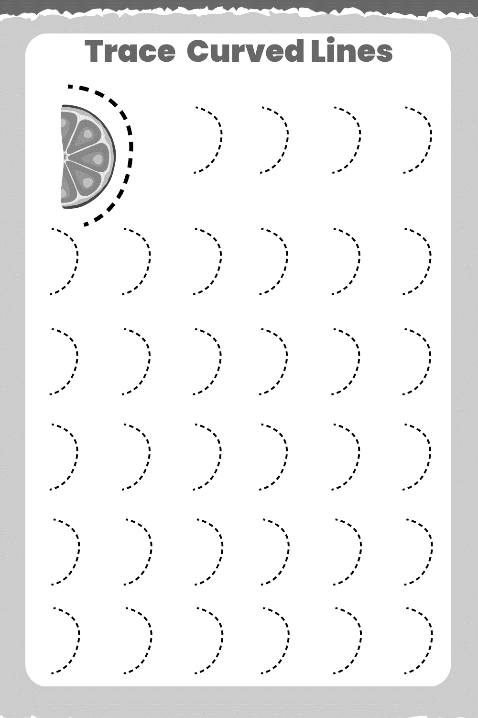

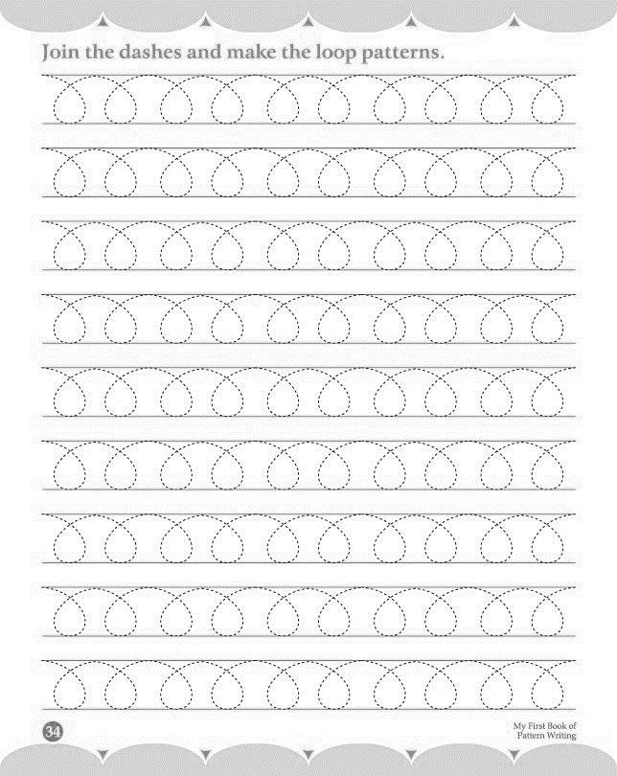

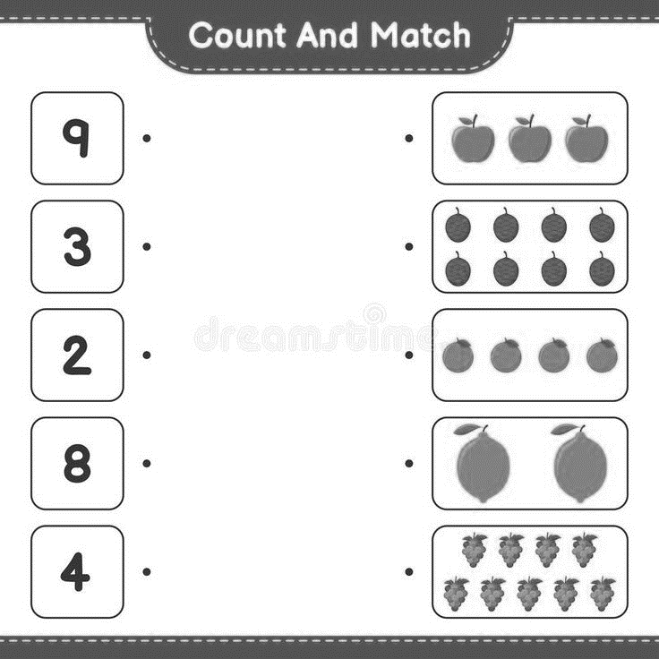

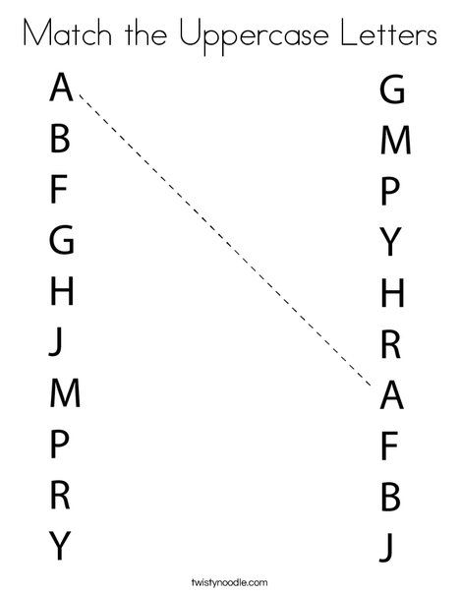

* **Colour: orange to petals, yellow to face, green to leaves , brown to stem**

